Handwriting Without Tears
Pre-K Readiness & Writing and Literacy and Math Workshop
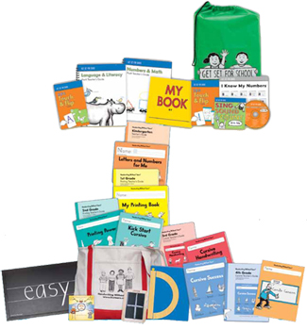
CESA #12 Conference Center

May 3, 2013

Registration: 8:30-9:00 AM

Training: 9:00 AM - 3:30 PM

Overview

Handwriting Without Tears is a developmentally based, child friendly approach to writing. It helps children build a solid foundation for success in the classroom. Recent findings demonstrate writing by hand improves creative writing skills and fine motor skills. This workshop is effective for anyone who wants to make handwriting easy and motivating for their students.

With the adoption of Common Core State Standards, the emphasis and expectations are changing, especially for young children around writing. Through this workshop one will understand a developmental approach to pre-writing and beginning printing skills, leave with an understanding of “how” to promote readiness skills, and learn new ways to teach developmentally appropriate activities for learning math (number recognition, shapes, math awareness) and literacy skills (beginning sound, language, letter, and words). Attendee’s will also learn how to implement strategies for differentiated instruction and learn how to integrate activities for sensory motor and social emotional development.

Presenter
Roxanne Thompson, OTR
Roxanne Thompson received her Bachelor of Science in Occupational Therapy from Texas Woman’s University in 1998. She has worked in the public schools, early intervention, and a private pediatric out-patient clinic. She also provides handwriting tutoring services to children in pre-school through middle school. She gets most of her hands-on practice with her own two children! She completed her Level 1 certification in March 2007 and is a National Workshop Presenter for HWT. Roxanne lives in Frisco with her husband and children.

Wisconsin State Performance Plan Indicators & Standards Addressed

Wisconsin's State Performance Plan Indicators: 7
Wisconsin Teacher Standards Addressed: 1,2,3,4,5,7

Target Audience
- 4 Year Old Kindergarten Teachers • OT’s
- Early Childhood Special Education • Administrators
- Kindergarten Teachers • Head Start Teachers
- Child Care Teachers

REGISTRATION FEE: $122 per participant which includes the “Handwriting Without Tears” Kit. This workshop has been made possible by the Early Childhood Curriculum & Assessment Network (ECCAN) through DPI and funding from the IDEA Preschool Discretionary Grant Project #13-74-9912 (PIDEA60) CFDA #84.173)

Deadline for Registration
April 22, 2013
(Early registration is necessary to give us time to order the kits.)

Registration cancelled after registration deadline will not be refunded)

Please register by going to: www.myquickreg.com

